# ABSTRACT

The pollution has increased with times by lot of factors like the increase in air population, increased vehicle use, industrialization and urbanization which results the pollution in nature which affects on human wellbeing. We propose an air quality monitoring system that allows us to monitor and check live air quality level in the area by our system. System uses MQ135 sensors to sense presence of harmful gases/compounds in the air and constantly transmit this data. This keeps measuring air quality level and reports it. The sensors interact with Arduino uno contains microcontroller (atmega 328) processes this data and transmits it over the application. This allows the owner of the device to monitor air pollution in different areas with the data and act against it. Also, owner can keep a watch on the air pollution near schools, hospitals give measurements of air pollution concentrations, which then can analyse interpreted and presented. By analysing the data allows us to assess how bad air pollution is from day to day. Air pollution is a big problem in the nature, as it costs more damage in evolution of human health, ecosystems, and the climate. Quality of the air in city and urban areas is the most important factor that directly influences the incidence of diseases and decreases the quality of life

# 1. Introduction

## Project Background

In the era of globalization challenges, health is an important element in our lives. Various diseases involving respiratory such as asthma and cough, acute cardiovascular disease and adverse pregnancy outcomes can be acquired chiefly derived from polluted air. Besides that, air pollution could have the greatest impact on the environment. Global warming phenomena that threaten our earth in recent years is closely related to the level of air pollution that caused by vast amount of carbon emission from vehicle petrol and diesel combustion, waste from everexpanding production industry, uncontrolled combustion of fossil fuel and open-air burning in the waste management site.

## India’s Air Pollution

In 2019, as part of a worldwide survey, it was discovered that 21 out of the 30 most polluted cities were in India. And this pushed India’s ranking as a country to 5th place, according to figures published by iqair.com. The US AQI number averaged out at 152 and the PM2.5 figure recorded was 58.08µg/m³. This concentration was 5 times higher than that recommended by the World Health Organisation (WHO). This is an overall improvement on the 2018 figure of 72.54µg/m³. This means serious health problems for most of the country.

Over 50 over cent of this pollution comes from industry, followed by 27 per cent from vehicles, 17 per cent from crop burning and 7 per cent by domestic cooking. Over 2 million Indians lose their life to causes attributed to air pollution.In the urban areas, most of the pollution comes from industry and vehicles, whereas in the rural areas, most comes from the burning of organic material. This material is used as a fuel for the domestic stoves, and also in the heaters needed to keep the houses warm in the colder months. During autumn and winter, huge amounts of stubble are burnt in the fields as a way of preparing the ground for the next crop. This method is much cheaper than the alternative option of ploughing the residue back into the land. This can be particularly bad as garbage is often thrown into the fires by way of disposal.

This combines with other pollutants to rank India as the world’s third greatest producer of greenhouse gases, behind China and the USA. The Air (Prevention and Control of Pollution) Act was inaugurated in the early ‘80s but has failed to make an impact due to the poor

enforcement of the rules.Official attitudes to the poor air quality is changing, especially since schools in Delhi had to close for several days in December 2017 due to the dangerous levels of pollutants present in the air. As more people are aware of the consequences of breathing poor quality air, the pressure is mounting on the authorities to do something about it.

## The Sources of India’s Polluted Air

Fuel used for domestic stoves is usually made from a wet mixture of pieces of wood, dried leaves, hay and dried animal dung. This is fashioned into discs and dried in the sunshine. When it is burned in the stoves or chullas, it produces smoke and other pollutants five times higher than if coal were burnt. It is thought that in excess of 100 million households use these stoves up to 3 times a day, 7 days a week. Electricity or other clean fuels are not available in many remote areas. Even in cities where electricity is available, it is traditional to use these types of stove and 24 percent of city pollutants are attributed to such habits.

Some Indian auto-rickshaws and taxis run on fuel that has been adulterated by other, cheaper ingredients. This is a common occurrence in all of South Asia. The taxation system in India exacerbates this situation because gasoline carries a much higher rate of tax than diesel. This, in turn, carries a higher level than kerosene because kerosene is intended to be used as a cooking fuel. Other volatile liquids such as lubricants and solvents carry little or no tax and therefore make ideal ingredients to mix with the higher-priced fuels. To a low wage earner, this adulteration can save as much as 30 per cent over the period of one month.

Traffic congestion is a huge problem in India’s large cities and towns due to the number of cars trying to use what roads are available. Other factors include a lack of intra-city divided highways and traffic accidents due to the chaotic conditions on India’s roads due to the lackadaisical enforcement of the laws. Because of the bottle-necks created by junctions, traffic remains at a standstill with the engines idling. Monitoring stations near some of the large intersections record noticeably higher figures than those recorded elsewhere.Dust produced from the demolition and subsequent building of new properties contributes to the poor quality of air in the city. During the dry season, dust is blown in from the desert-dry countryside and deposited in the city when the wind pressure drops as it travels over the buildings.

The air quality in the capital of Delhi always drops to the “severe” category during the winter months. Primarily, this is due to the practice of burning the stubble after the harvest to prepare

for the planting of next season’s crop. It is reported that this alone is responsible for 32 per cent of Delhi’s PM2.5 particulate matter. At 292micrograms per cubic metre, the figure is 5 times higher than the World Health Organisation’s recommended safe limit. Weather conditions play an important part in the dispersal of airborne particles through both wind and rain.

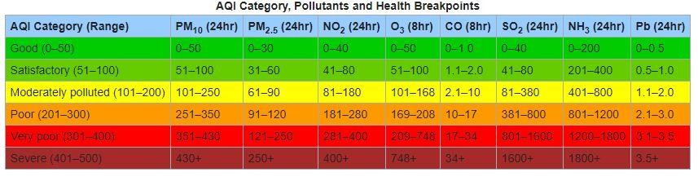

Another major contributor to the air pollution was the Badarpur Thermal Power Station. This was built in 1973 and produced a mere 8 per cent of Delhi’s electricity yet was accountable for 80-90 per cent of the particulate matter. In November 2017 during “[The Great Smog of Delhi](https://www.iqair.com/india/delhi)” it was temporarily shut down to alleviate the smog but restarted the following February. However, due to the amount of pollution it created, it was shut down permanently in late 2018.

Fig 1. 1 AQI of India

|  |  |
| --- | --- |
| **AQI** | **Associated Health Impacts** |
| Good (0-50) | Minimal impact |
| Satisfactory (51–100) | discomfort to sensitive people. |
| Moderately polluted (101–200) | May cause breathing discomfort to people with lung disease such  as asthma, and discomfort to people with heart disease, children and older adults. |
| Poor (201–300) | May cause breathing discomfort to people on prolonged exposure,  and discomfort to people with heart disease. |
| Very poor (301–400) | May cause respiratory illness to the people on prolonged exposure.  Effect may be more pronounced in people with lung and heart diseases. |
| Severe (401–500) | May cause respiratory impact even on healthy people, and serious health impacts on people with lung/heart disease. The health  impacts may be experienced even during light physical activity |

Table 1. 1 Pollution’s Health Impacts

## Problem Statement

Air pollution index (API) is basically a scale to gauge the severity or how polluted the air is. The greater number of the API represents the more dangerous the air quality to human health. The unpredictable weather that occurred in our country in recent months has exposed our environment towards to natural disasters especially fire which results in hazy environment. Haze will definitely affect the API in that particular area where the fire occurs. On the other hand, industrial waste such as unreacted gas could also affect the API especially the area nearby the industrial area. Nowadays, individual who wants to have an API system has to pay a fortune because the installation cost is very high and expensive. The size is also large and not portable. These systems are usually used by government’s bodies and large companies who own industrial plants to monitor the air quality. This project has been proposed to produce a cheaper version of API system and portable using cheaper materials costs

## Objective

There are few objectives that need to be achieved at the end of this project. The objectives of this project are:

* + 1. To design a low cost and portable air pollutant index (API) using particle and gas sensor;
    2. To integrate the sensor, Arduino microcontroller and GSM module to form a complete API system.
    3. To transmit and receive Air pollution index (API) data via short message service (SMS) using GSM.

## Project Scope

In order to achieve the objectives of the project, several scopes have been outlined. The following are the scopes of the project:

* + 1. Use a suitable sensor and signal conditioning circuit to detect air quality pollutant at surrounding.
    2. Create suitable program coding for reading a data from sensor to Arduino microcontroller.
    3. Create a suitable command GSM system to send the data received from Arduino microcontroller and send data to sever.

## Literature Review

The drawbacks of the conventional monitoring instruments are their large size, heavy weight and extraordinary expensiveness. These lead to sparse deployment of the monitoring stations. In order to be effective, the locations of the monitoring stations need careful placement because the air pollution situation in urban areas is highly related to human activities (e.g. construction activities) and location-dependent (e.g., the traffic choke-points have much worse air quality than average). IOT Based Air Pollution Monitoring System monitors the Air Quality over a webserver using internet and will trigger an alarm when the air quality goes down beyond a certain level, means when there are amount of harmful gases present in the air like CO2, smoke, alcohol, benzene, NH3, NOx and LPG. The system will show the air quality in PPM on the LCD

and as well as on webpage so that it can be monitored very easily. Temperature and Humidity is detected and monitored in the system LPG gas is detected using MQ6 sensor and MQ135 sensor is used for monitoring Air Quality as it detects most harmful gases and can measure their amount accurately. In this IOT project, it can monitor the pollution level from anywhere using your computer or mobile. This system can be installed anywhere and can also trigger some device when pollution goes beyond some level, like we can send the data to the sever.

Chapter 2

# 2. Project Requirements

## Hardware Requirement

1. Arduino Uno
2. Wi-Fi module ESP8266
3. 16x2 LCD
4. MQ135 Gas sensor
5. MQ 7 LPG gas sensor
6. Buzzer

## Arduino UNO

The Arduino Uno R3 is a microcontroller board based on a removable, dual-inline- package (DIP) ATmega328 AVR microcontroller. It has 20 digital input/output pins (of which 6 can be used as PWM outputs and 6 can be used as Analog inputs). Programs can be loaded on to it from the easy-to-use Arduino computer program. The Arduino has an extensive support community, which makes it a very easy way to get started working with embedded electronics. The R3 is the third, and latest, revision of the Arduino Uno.

Arduino can be used to communicate with a computer, another Arduino board or other microcontrollers. The Atmega328P microcontroller provides UART TTL (5V) serial communication which can be done using digital pin 0 (Rx) and digital pin 1 (Tx). An Atmega16U2 on the board channels this serial communication over USB and appears as a virtual com port to software on the computer. The Atmega16U2 firmware uses the standard USB COM drivers, and no external driver is needed. However, on Windows, a .inf file is required. The Arduino software includes a serial monitor which allows simple textual data to be sent to and from the Arduino board. There are two RX and TX LEDs on the Arduino board which will flash when data is being transmitted via the USB-to-serial chip and USB connection to the computer (not for serial communication on pins 0 and 1). A Software Serial library allows for serial communication on any of the Uno’s digital pins. The Atmega328P also supports I2C

(TWI) and SPI communication. The Arduino software includes a Wire library to simplify use of the I2C bus.

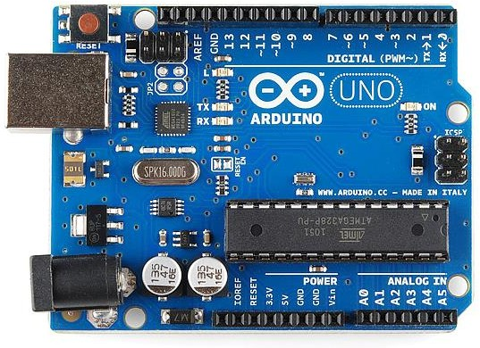

Fig 2. 1 Arduino UNO

The 14 digital input/output pins can be used as input or output pins by using pinMode(), digitalRead() and digitalWrite() functions in 9rduino programming. Each pin operate at 5V and can provide or receive a maximum of 40mA current, and has an internal pull-up resistor of 20- 50 Kohms which are disconnected by default. Out of these 14 pins, some pins have specific functions as listed below:

* Serial Pins 0 (Rx) and 1 (Tx): Rx and Tx pins are used to receive and transmit TTL serial data. They are connected with the corresponding Atmega328P USB to TTL serial chip.
* External Interrupt Pins 2 and 3**:** These pins can be configured to trigger an interrupt on a low value, a rising or falling edge, or a change in value.
* PWM Pins 3, 5, 6, 9 and 11**:** These pins provide an 8-bit PWM output by using analogWrite() function.
* SPI Pins 10 (SS), 11 (MOSI), 12 (MISO) and 13 (SCK): These pins are used for SPI communication.
* In-built LED Pin 13: This pin is connected with a built-in LED, when pin 13 is HIGH

– LED is on and when pin 13 is LOW, its off.

Along with 14 Digital pins, there are 6 analog input pins, each of which provide 10 bits of resolution, i.e., 1024 different values. They measure from 0 to 5 volts, but this limit can be increased by using AREF pin with analog Reference () function.

* Analog pin 4 (SDA) and pin 5 (SCA) also used for TWI communication using Wire library.
  + - 1. ***Pin Description:***

|  |  |  |
| --- | --- | --- |
| **Pin Category** | **Pin Name** | **Details** |
| Power | Vin, 3.3V,  5V, GND | Vin: Input voltage to Arduino when using an external power source.  5V: Regulated power supply used to power microcontroller and other components on the board.  3.3V: 3.3V supply generated by on-board voltage regulator. Maximum current draw is 50mA.  GND: ground pins. |
| Reset | Reset | Resets the microcontroller. |
| Analog Pins | A0 – A5 | Used to provide analog input in the range of 0-5V |
| Input/Output Pins | Digital Pins 0 – 13 | Can be used as input or output pins. |
| Serial | 0(Rx), 1(Tx) | Used to receive and transmit TTL serial data. |
| External  Interrupts | 2, 3 | To trigger an interrupt. |
| PWM | 3, 5, 6, 9, 11 | Provides 8-bit PWM output. |
| SPI | 10 (SS), 11  (MOSI),  12 (MISO) and  13 (SCK) | Used for SPI communication. |
| Inbuilt LED | 13 | To turn on the inbuilt LED. |
| TWI | A4 (SDA), A5 (SCA) | Used for TWI communication. |
| AREF | AREF | To provide reference voltage for input voltage. |

Table 2. 1 Pin Description of Arduino UNO

## Wi-Fi MODULE ESP8266

The ESP8266 WiFi Module is a self-contained SOC with integrated TCP/IP protocol stack that can give any microcontroller access to your WiFi network. The ESP8266 is capable of either hosting an application or offloading all WiFi networking functions from another application processor. Each ESP8266 module comes pre-programmed with an AT command set firmware, meaning, you can simply hook this up to your Arduino device and get about as much WiFi-ability as a WiFi Shield offers (and that's just out of the box)! The ESP8266 module is an extremely cost effective board with a huge, and ever growing, community.

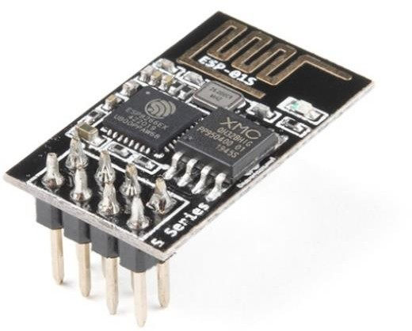

Fig 2. 2 Wi-Fi MODULE ESP8266

This module has a powerful enough on-board processing and storage capability that allows it to be integrated with the sensors and other application specific devices through its GPIOs with minimal development up-front and minimal loading during runtime. Its high degree of on-chip integration allows for minimal external circuitry, including the front-end module, is designed to occupy minimal PCB area. The ESP8266 supports APSD for VoIP applications and Bluetooth co-existance interfaces, it contains a self-calibrated RF allowing it to work under all operating conditions, and requires no external RF parts.

There is an almost limitless fountain of information available for the ESP8266, all of which has been provided by amazing community support. In the *Documents* section below you will find many resources to aid you in using the ESP8266, even instructions on how to transform this module into an IoT (Internet of Things) solution.

## 16x2 LCD

The term [LCD stands for liquid crystal display](https://www.elprocus.com/difference-alphanumeric-display-and-customized-lcd/). It is one kind of electronic display module used in an extensive range of applications like various circuits & devices like mobile phones, calculators, computers, TV sets, etc. These displays are mainly preferred for multi- segment [light-emitting diodes](https://www.elprocus.com/light-emitting-diode-led-working-application/) and seven segments. The main benefits of using this module are inexpensive; simply programmable, animations, and there are no limitations for displaying custom characters, special and even animations, etc.

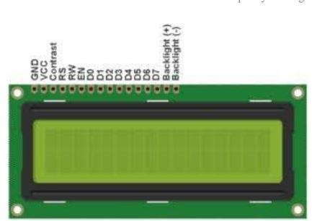

Fig 2. 3 16x2 LCD Display

A liquid-crystal display (LCD) is a flat-panel display or other electronically modulated optical device that uses the light-modulating properties of liquid crystals. Liquid crystals do not emit light directly, instead using a backlight or reflector to produce images in color or monochrome.

1. LCDs are available to display arbitrary images (as in a general-purpose computer display) or fixed images with low information content, which can be displayed or hidden, such as preset words, digits, and seven-segment displays. The 16×2 LCD pinout is shown below: -
   * Pin1 (Ground/Source Pin): This is a GND pin of display, used to connect the GND terminal of the microcontroller unit or power source.
   * Pin2 (VCC/Source Pin): This is the voltage supply pin of the display, used to connect the supply pin of the power source.
   * Pin3 (V0/VEE/Control Pin): This pin regulates the difference of the display, used to connect a changeable POT that can supply 0 to 5V.
   * Pin4 (Register Select/Control Pin): This pin toggles among command or data register, used to connect a microcontroller unit pin and obtains either 0 or 1(0 = data mode, and 1 = command mode).
   * Pin5 (Read/Write/Control Pin): This pin toggles the display among the read or writes operation, and it is connected to a microcontroller unit pin to get either 0 or 1 (0 = Write Operation, and 1 = Read Operation).
   * Pin 6 (Enable/Control Pin): This pin should be held high to execute Read/Write process, and it is connected to the microcontroller unit & constantly held high.
   * Pins 7-14 (Data Pins): These pins are used to send data to the display. These pins are connected in two-wire modes like 4-wire mode and 8-wire mode. In 4-wire mode, only four pins are connected to the microcontroller unit like 0 to 3, whereas in 8-wire mode, 8-pins are connected to microcontroller unit like 0 to 7.
   * Pin15 (+ve pin of the LED): This pin is connected to +5V
   * Pin 16 (-ve pin of the LED): This pin is connected to GND.

### Pin Description:

|  |  |  |
| --- | --- | --- |
| **PIN NO.** | **FUNCTION** | **NAME** |
| **1.** | Ground (0V) | Ground |
| **2.** | Supply voltage; 5V (4.7V – 5.3V) | Vcc |
| **3.** | Contrast adjustment; through a variable resistor | Vee |
| **4.** | Selects command register when low; and data  register when high | Register Select |
| **5.** | Low to write to the register; High to read from the  register | Read/write |
| **6.** | Sends data to data pins when a high to low pulse is  given | Enable |
| **7.** | 8-bit data pins | DB0 |
| **8.** | DB1 |
| **9.** | DB2 |
| **10.** | DB3 |
| **11.** | DB4 |
| **12.** | DB5 |
| **13.** | DB6 |
| **14.** | DB7 |
| **15.** | Backlight VCC (5V) | Led+ |
| **16.** | Backlight Ground (0V) | Led **-** |

Table 2. 2 Pin Description of 16x2 LCD Display

## MQ-135 GAS SENSOR

The MQ 135 Air Quality Detector Sensor Module for Arduino has lower conductivity in clean air. When the target combustible gas exists, the conductivity of the sensor is higher along with the gas concentration rising.

Convert change of conductivity to the corresponding output signal of gas concentration. The MQ135 gas sensor has a high sensitivity to Ammonia, Sulphide, and Benzene steam, also sensitive to smoke and other harmful gases.

It is with low cost and suitable for different applications such as harmful gases/smoke detection. The Air quality sensor detects ammonia, nitrogen oxide, smoke, CO2, and other harmful gases. The air quality sensor has a small potentiometer that permits the adjustment of the load resistance of the **s**ensor circuit. The 5V power supply is used for air quality sensor.

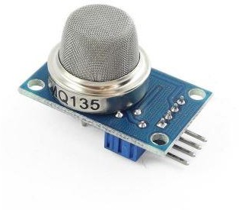

Fig 2. 4 MQ-135 Gas Sensor

## Pin Description:

**1**. The VDD power supply 5V DC

**2**, GND, used to connect the module to system ground

1. DIGITAL OUT, you can also use this sensor to get digital output from this pin, by setting a threshold value using the potentiometer
2. ANALOG OUT, this pin outputs 0-5V Analog voltage based on the intensity of the gas.

## MQ-7 GAS SENSOR

Sensitive material of MQ-7 gas sensor is SnO2, which with lower conductivity in clean air. It make detection by method of cycle high and low temperature, and detect CO when low temperature (heated by 1.5V).

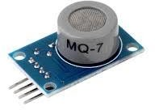

Fig 2. 5 MQ-7 Gas Sensor

The sensor’s conductivity is more higher along with the gas concentration rising. When high temperature (heated by 5.0V), it cleans the other gases adsorbed under low temperature.

Please use simple electro-circuit, convert change of conductivity to correspond output signal of gas concentration. MQ-7 gas sensor has high sensitivity to Carbon Monoxide. The sensor could be used to detect different gases contains CO, it is with low cost and suitable for different application.

## BUZZER

The buzzer consists of an outside case with two pins to attach it to power and ground. ...

When current is applied to the buzzer it causes the ceramic disk to contract or expand. Changing the This then causes the surrounding disc to vibrate. That's the sound that you hear.

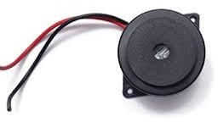

Fig 2. 6 Buzzer

## Software Requirements

In our project we specially need here a software to upload the code to Arduino which is following below:

## Arduino IDE

The Arduino Integrated Development Environment ([IDE](https://en.wikipedia.org/wiki/Integrated_development_environment)) is a [cross-platform](https://en.wikipedia.org/wiki/Cross-platform) application (for [Windows,](https://en.wikipedia.org/wiki/Windows) [macOS,](https://en.wikipedia.org/wiki/MacOS) [Linux](https://en.wikipedia.org/wiki/Linux)) that is written in functions from [C](https://en.wikipedia.org/wiki/C_(programming_language)) and [C++](https://en.wikipedia.org/wiki/C%2B%2B_(programming_language)). It is used to write and upload programs to [Arduino](https://en.wikipedia.org/wiki/Arduino) compatible boards, but also, with the help of third-party cores, other vendor development boards.

The source code for the IDE is released under the [GNU General Public License](https://en.wikipedia.org/wiki/GNU_General_Public_License), version 2. The Arduino IDE supports the languages [C](https://en.wikipedia.org/wiki/C_(programming_language)) and [C++](https://en.wikipedia.org/wiki/C%2B%2B) using special rules of code structuring. The Arduino IDE supplies a [software library](https://en.wikipedia.org/wiki/Software_library) from the [Wiring](https://en.wikipedia.org/wiki/Wiring_(development_platform)) project, which provides many common input and output procedures. User-written code only requires two basic functions, for starting the sketch and the main program loop, that are compiled and linked with a program stub *main()* into an executable [cyclic executive](https://en.wikipedia.org/wiki/Cyclic_executive) program with the [GNU toolchain](https://en.wikipedia.org/wiki/GNU_toolchain), also included with the IDE distribution. The Arduino IDE employs the program *avrdude* to convert the executable code into a text file in hexadecimal encoding that is loaded into the Arduino board by a loader program in the board's firmware. By default, avrdude is used as the uploading tool to flash the user code onto official Arduino boards.

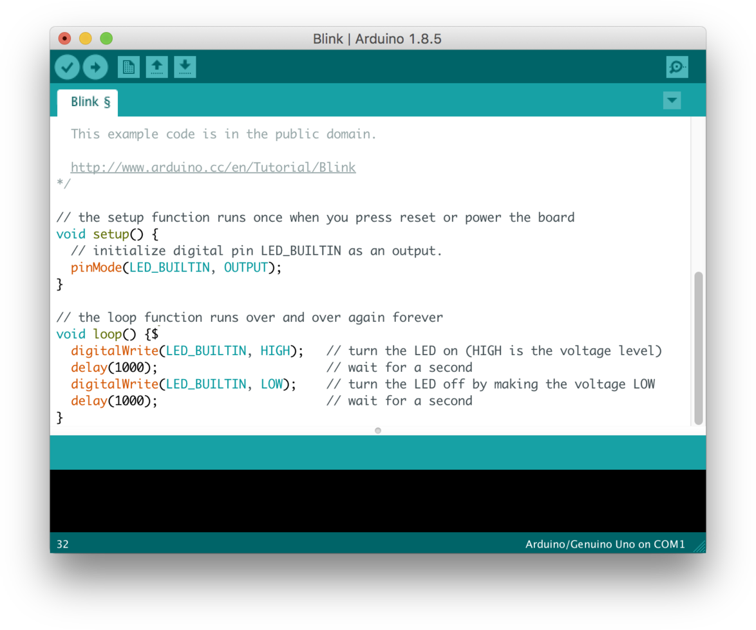Arduino IDE is a derivative of the [Processing IDE](https://en.wikipedia.org/wiki/Processing_(programming_language)), however as of version 2.0, the Processing IDE will be replaced with the [Visual Studio Code](https://en.wikipedia.org/wiki/Visual_Studio_Code)-based [Eclipse Theia](https://en.wikipedia.org/wiki/Eclipse_Theia) IDE framework.

Fig 2. 7 Interface of Arduino IDE Software

With the rising popularity of Arduino as a software platform, other vendors started to implement custom open source compilers and tools (cores) that can build and upload sketches to other [microcontrollers](https://en.wikipedia.org/wiki/Microcontroller) that are not supported by Arduino's official line of microcontrollers.

There are many other microcontrollers and microcontroller platforms available for physical computing. Parallax Basic Stamp, Netmedia's BX-24, Phidgets, MIT's Handyboard, and many others offer similar functionality. All of these tools take the messy details of microcontroller programming and wrap it up in an easy-to-use package. Arduino also simplifies the process of working with microcontrollers, but it offers some advantage for teachers, students, and interested amateurs over other systems:

* Inexpensive - Arduino boards are relatively inexpensive compared to other microcontroller platforms. The least expensive version of the Arduino module can be assembled by hand, and even the pre-assembled Arduino modules cost less than $50
* Cross-platform - The Arduino Software (IDE) runs on Windows, Macintosh OSX, and Linux operating systems. Most microcontroller systems are limited to Windows.
* Simple, clear programming environment - The Arduino Software (IDE) is easy-to-use for beginners, yet flexible enough for advanced users to take advantage of as well. For teachers, it's conveniently based on the Processing programming environment, so students learning to program in that environment will be familiar with how the Arduino IDE works.
* Open source and extensible software - The Arduino software is published as open source tools, available for extension by experienced programmers. The language can be expanded through C++ libraries, and people wanting to understand the technical details can make the leap from Arduino to the AVR C programming language on which it's based. Similarly, you can add AVR-C code directly into your Arduino programs if you want to.
* Open source and extensible hardware - The plans of the Arduino boards are published under a Creative Commons license, so experienced circuit designers can make their own version of the module, extending it and improving it. Even relatively inexperienced users can build the [breadboard version of the module](https://www.arduino.cc/en/Main/Standalone) in order to understand how it works and save money.

Chapter 3

# 3. Project Working Principal

## Working Principal

The major chip of the system is MQ7 and MQ135 are gas sensing analysis. The Arduino Uno is a modern microcontroller board based on the ATmega328P. It is simply related to a computer by a USB link or power. Connected to an AC-to-DC convertor or battery source to become commenced. Using jumper wires the MQ135 gas sensor unit is linked to the arduino Uno board. The sensors analog pin is then related to the analog pin 0 and digital pin to digital 8 on the Arduino board, while +5V and the GND (ground) pins on the sensor unit are linked to the 5V Vcc and GND (ground) pin correspondingly on the Arduino board. Using USB connection, the Arduino Uno board is then linked to a computer system. This part elaborates the hardware and software instruments and structural design of the detector. A harmful gas recognition device for the people, the environment that is appropriate for. A wide variety of gases is detected in air quality sensor comprising NH3, NO2, benzene, alcohol, smoke, and CO2. The collection of air pollutants like CO2, CO, SO2, etc. is greatly location. Very simple device, and monitoring circuit which is perfect for use in office or factory. using the serial library of the Arduino. The attention of the gas measured hinge on upon the resistance of the gas sensor. Additionally, this depends on the sensor of the voltage of the analog output pin. The sensor revisits an analog voltage to the Arduino.

## Block Diagram

The block diagram of Air pollution monitoring system is given below:

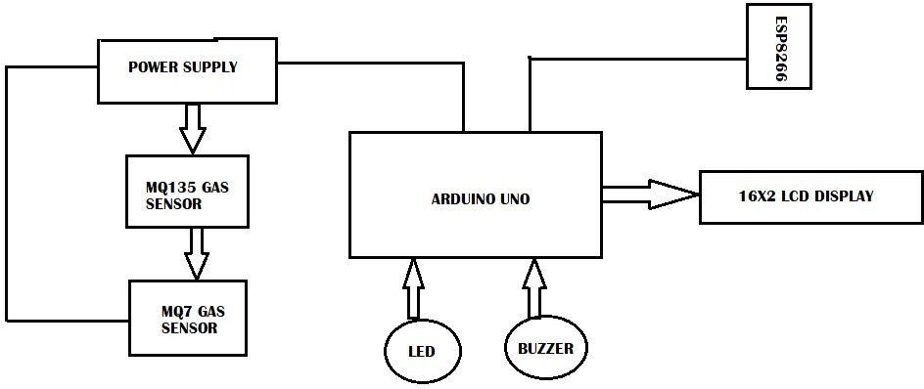

Fig 3. 1 Block Diagram of Air Quality Monitoring and Sensing

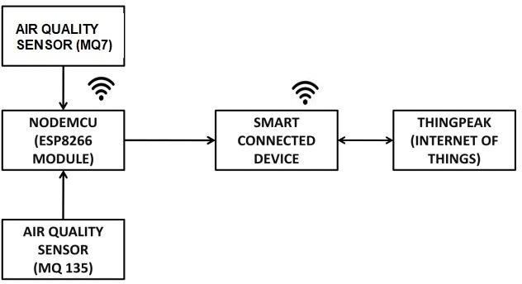

Fig 3. 2 Block Diagram of sending the data to THINGSPEAK using NodeMCU

## Circuit Diagram

The circuit diagram of Air Quality Monitoring System is given below diagram:

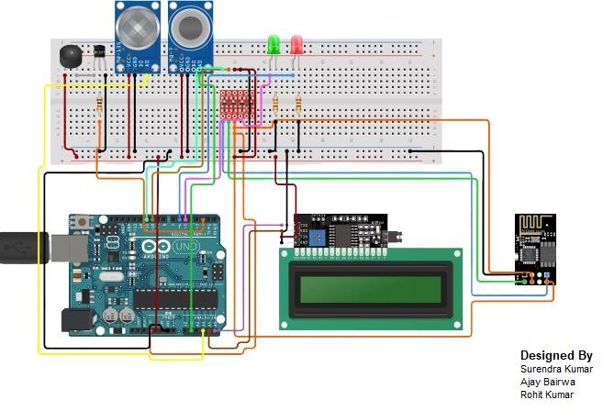

Fig 3. 3 Circuit Diagram of Air Pollution Monitoring System

# CONCLUSION

This research proposed a smart air pollution monitoring system that constantly keeps track of air quality in an area and displays the air quality measured on an LCD screen the system helps to create awareness of the Quality of air that one breathes daily. This monitoring device can deliver real-time Measurements of air quality. The system to monitor the air of environment using Arduino microcontroller proposed to improve quality of air. Here the using of MQ135 gas sensor gives the sense of different type of dangerous gas and Arduino is the heart of this project which controls the entire process and LCD is used for the visual Output. The Automatic Air management system is a step forward to contribute a solution to the biggest threat. The air & sound monitoring system overcomes the problem of the highly-polluted areas which is a major issue. It supports the new technology and effectively sup ports the healthy life concept.

# REFRENCE

* Arduino Uno: <https://www.arduino.cc/>
* MQ7 Datasheet: <https://www.sparkfun.com/datasheets/Sensors/Biometric/MQ-7.pdf>
* MQ135 Datasheet: [https://www.olimex.com/Products/Components/Sensors/Gas/SNS-](https://www.olimex.com/Products/Components/Sensors/Gas/SNS-MQ135/resources/SNS-MQ135.pdf) [MQ135/resources/SNS-MQ135.pdf](https://www.olimex.com/Products/Components/Sensors/Gas/SNS-MQ135/resources/SNS-MQ135.pdf)
* <http://www.arduinohobby.euweb.cz/toppage7.htm>
* <https://www.irjet.net/archives/V7/i6/IRJET-V7I632.pdf>
* Thingspeak: <https://thingspeak.com/>
* <https://pridopia.co.uk/pi-doc/ESP8266ATCommandsSet.pdf>
* <https://automeris.io/WebPlotDigitizer/>
* Systems, J. (2016, May 09). Understanding a Gas Sensor. Retrieved from <https://jayconsystems.com/blog/understanding-a-gas-sensor>
* [http://davidegironi.blogspot.com/2017/05/mq-gas-sensor-correlation-](http://davidegironi.blogspot.com/2017/05/mq-gas-sensor-correlation-function.html#.YLmv1vkzaMo) [function.html#.YLmv1vkzaMo](http://davidegironi.blogspot.com/2017/05/mq-gas-sensor-correlation-function.html#.YLmv1vkzaMo)
* Cho, R. (2018, June 26). What you should know about air quality alerts. Retrieved from <https://phys.org/news/2018-06-airquality.html>

# 

# 